| Program Name: | 10 |
| --- | --- |
| Roll No: | 1510 |
| Title of Program: | Stack - array implementation |
| Objective: | Array Based Stacks with options to:   1. Push 2. Pop 3. Peek 4. Display |

**CODE:**

/*

Name: Advait Dhakad

Roll No: 1510

Unit 3: Stack

Program: Stack - array implementation

*/

import java.util.Scanner;

class stack{

int max;

int [] sArray;

int tos;

stack(int size){

max = size;

sArray = new int[max];

tos = -1;

}// end constructor

void push(int ele){

if (tos>=max-1){

System.out.println("OVERFLOW");

}

else{

sArray[++tos]=ele;

}

}// end of push

int pop(){

if(tos<0){

System.out.println("UNDERFLOW");

return -1;

}

else{

return sArray[tos--];

}

}// end of pop

void display(){

for(int i = tos; i>=0;i--)

{

System.out.println("| "+sArray[i]+"|");

}

System.out.println("--------");

}// end of display

int peek(){

if(tos<0){

System.out.println("The stack is empty");

return -1;

}

else

return sArray[tos];

}// end of peek

boolean isFull(){

if (tos>=max-1){

return true;

}

else{

return false;

}

}// end of isFull

boolean isEmpty(){

if(tos<0){

return true;

}

else{

return false;

}

}// end of Empty

} //end of stack

class stack_impl_array{

public static void main(String[] args){

Scanner scan = new Scanner(System.in);

System.out.print("Enter the size of the Stack:");

stack s = new stack(scan.nextInt());

char ch;

do{

System.out.print("\033[H\033[2J");

System.out.flush();

System.out.println("\n");

System.out.println("\t******* STACK with array ************* \n");

System.out.println(" 1 . PUSH");

System.out.println(" 2 . POP");

System.out.println(" 3 . Display the Stack");

System.out.println(" 4 . PEEK");

System.out.println(" 5 . IsFull");

System.out.println(" 6 . IsEmpty \n");

System.out.print("Enter your Choice: ");

int choice = scan.nextInt();

switch(choice){

case 1:

System.out.println("Selected PUSH");

System.out.print("Enter the data you want insert: ");

s.push(scan.nextInt());

break;

case 2:

System.out.println("Selected POP");

System.out.println(s.pop()<0? " The element was popped": " There was underflow no element popped");

break;

case 3:

System.out.println("Selected to Display the Stack");

s.display();

break;

case 4:

System.out.println("Selected to PEEK");

System.out.println("The element at TOS is: "+s.peek());

break;

case 5:

System.out.println("Selected to check if stack is full");

System.out.println(s.isFull()==true? "The Stack is full":"The stack is not full");

break;

case 6:

System.out.println("Selected to check if stack is Empty");

System.out.println(s.isEmpty()==true? "The Stack is Empty":"The stack is not empty ");

break;

default:

System.out.println("Wrong choice!!");

break;

}// end of switch

System.out.print("Do you Want to Countinue(y or Y for yes):" );

ch = scan.next().charAt(0);

}while(ch=='y' || ch=='Y'); // end of while

}

} // end of stack_impl

**OUTPUT:**

Initializing the array:

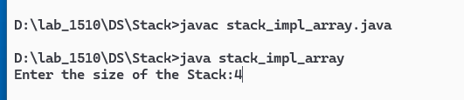

Pushing in the array:

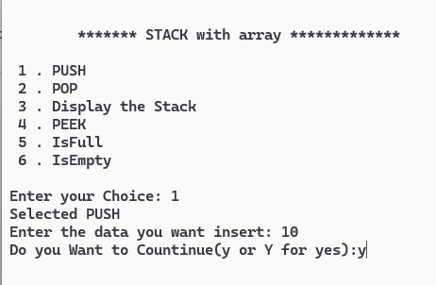

OVERFLOW

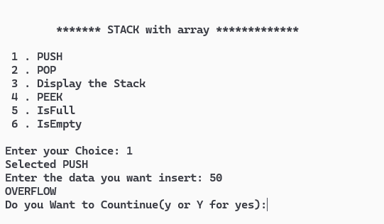

Display:

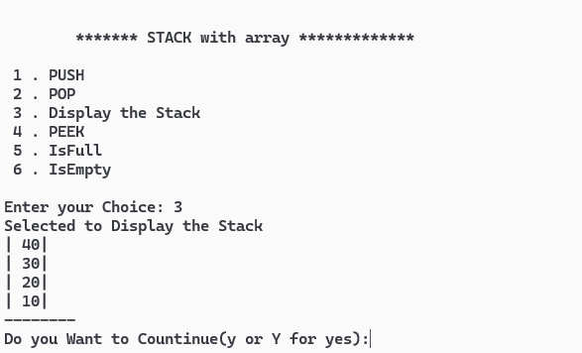

Peek:

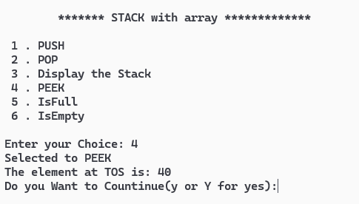

Popping an element:

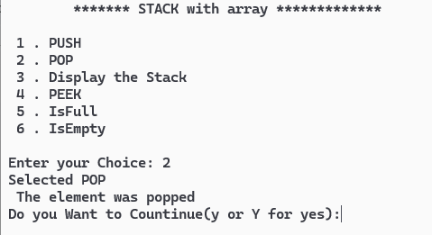

UNDERFLOW:

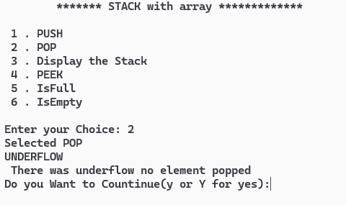

| IsFull | IsEmpty |
| --- | --- |
|  |  |
|  |  |